**Robo Phantoms**

**#23954**



**Website:** <https://sites.google.com/view/robophantoms?usp=sharing>

**YouTube**: <https://www.youtube.com/@user-jq7jn5wu3b>

**Instagram**: @robophantoms23954

Team

Dhruv Shah - Driver 1/CAD Designer

Kavin Sankaran - Head Programmer

Harsh Desai - Maintenance

Kayan Patel - Assistant Programmer

Srilakshminath Madasu - Driver 2/Builder

Coach:

Srinath Madasu

Team Mission Statement:

We are a rookie FTC team all in our first year. Our team includes 5 hardworking kids and 1 strong coach. We want to spread awareness for the FIRST organization to inspire other people our age and younger to get involved in the robotics and technology field at an early age. We were very excited when we got the opportunity to participate in FTC and want other people to also have the same experience and have fun while learning about robotics. We do this by conducting fundraisers and always telling our friends about FIRST. We are very dedicated and meet every week to work on our robot and do the best work we can to conduct “Gracious Professionalism”

2. GAME ANALYSIS

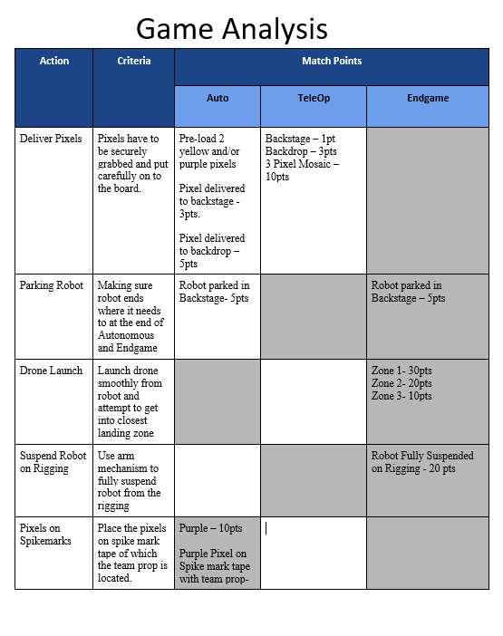

**3. Research**

**DRIVETRAINS**

| **Omni Wheels** | * Omni wheels have rubber rollers around the circumference of the wheel. This allows the wheel to roll perpendicular to the direction the wheel is driven. |
| --- | --- |
| **Mecanum Wheels** | * Each side requires one left wheel and one right wheel to operate. When set up correctly, this allows **omni-directional movement** (movement in all directions). |
| **Traction Wheel** | * Traction wheels are designed for **maximum grip.** * These are the regular forward and backward wheels. |

Intake/Outtake

| **Horizontal Intake** | The Horizontal Intake works by rotating on a horizontal  plane. This type of intake is best used for smaller game items. |
| --- | --- |
| **Vertical Intake** | The Vertical Intake works by using wheels or other  components to intake the object. |
| **Compliant Wheels** | Compliant wheels are pieces of wheel shaped rubber, usually  used for the Intake mechanism of a robot. |
| **Rubber Band Intakes** | Rubber Intakes are made by 2 wheels on either side and  rubber bands stretched in between them. This creates a sort of roller that can  intake balls. |
| **Surgical Tubing Intake** | Surgical Tubing Intakes can be spring loaded into the robot.  Mostly used when the robot needed to transport smaller objects to a higher or  elevated surface. |

Transfers

| **Flip up transfer** | The robot has a collector that intake the game element while the collector “Flips up” to transfer into a second mechanism” |
| --- | --- |
| **Direct transfer** | The robot intakes and transfers into a bucket for scoring |
| **Conveyor transfer** | Multiple items can be transferred, items can be continuously transferred |

Arms

| **Single arms** | Very easy to build , useful in low load applications |
| --- | --- |
| **Multi axis arms** | Can get in arm in multiple different angles |

Credits:

<https://gm0.org/en/latest/>

<https://www.ftctutorial.com/hardware/drivetrain>